**SQL**

**select * from loans**

**--total applications**

select count(id) as total_applications

from loans

output:



--**mtd--month to date**

select count(id) as mtd_total_applications

from loans

where month( issue_date) = 12

output:



**---pmtd--privious month to date**

select count(id) as pmtd_total_applications

from loans

where month( issue_date) = 11

output:



**--total funded amount**

select sum(loan_amount) as total_funded_amount

from loans

output:



**---mtd of funded amount**

select sum(loan_amount) as total_funded_amount_mtd

from lones

where month(issue_date) = 12

output:

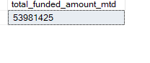

**---pmtd**

select sum(loan_amount) as total_funded_amount_mtd

from loans

where month(issue_date) = 11

output:

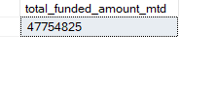

**---total receive amount**

**select * from loans**

select sum(total_payment) as total_received_amount

from loans

output:

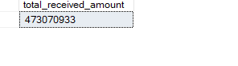

**---mtd**

select sum(total_payment) as mtd_total_received_amount

from loans

where month(issue_date) = 12

output:

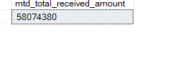

**----pmtd**

select sum(total_payment) as pmtd_total_received_amount

from loans

where month(issue_date) = 11

output:

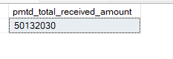

**---avg interst rate**

select round(avg(int_rate),4)*100 as avg_intrest_rate

from loans

output:

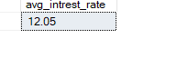

**---mtd**

select round(avg(int_rate),4)*100 as avg_interst_rate_of_mtd

from loans

where month(issue_date) = 12

output:

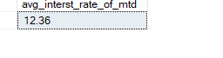

**--pmtd**

select round(avg(int_rate),4)*100 as avg_interst_rate_of_pmtd

from loans

where month(issue_date) = 11

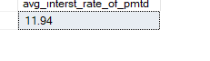

**---avg_dti**

select avg(dti)*100 as avg_dti

from loans

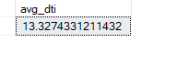

**---mtd**

select round(avg(dti),4)*100 as mtd_avg_dti

from loans

where month(issue_date) = 12

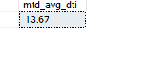

**--pmtd**

select round(avg(dti),4)*100 as pmtd_avg_dti

from loans

where month(issue_date) = 11

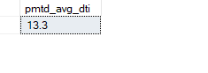

**----caliculate the good lone percentage**

**select * from loans**

SELECT

loan_status,

CASE

WHEN loan_status IN ('fully paid', 'current') THEN 'good loan'

ELSE 'bad loan'

END AS status

FROM loans

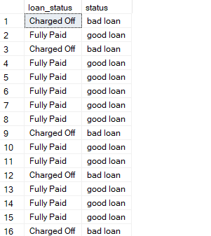

select

(count(case WHEN loan_status IN ('fully paid', 'current') then id

end) * 100.0) / count(id) as good_loan_percentage

from loans

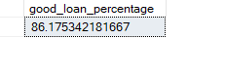

**----good loan applications**

select count(id) as good_loan_applications

from loans

where loan_status in ('fully paid', 'current')

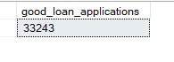

**----good lone funded amount**

select sum(loan_amount) as good_loan_funded_amount

from loans

where loan_status in ('fully paid', 'current')

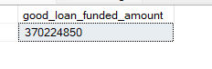

**----good lone received amount**

select sum(total_payment) as good_loan_received_amount

from loans

where loan_status in ('fully paid', 'current')



**----bad loan applications**

select count(id) as bad_loan_applications

from loans

where loan_status = 'charged off'



**----bad lone funded amount**

select sum(loan_amount) as bad_loan_funded_amount

from loans

where loan_status = 'charged off'



**----bad lone received amount**

select sum(total_payment) as bad_loan_received_amount

from loans

where loan_status = 'charged off'



**---lone status**

select

loan_status,

count(id) as total_applications,

sum (loan_amount) as total_funded_amount,

sum(total_payment) as total_received_amount,

avg(int_rate * 100) as avg_intrest_rate,

avg(dti * 100) as avg_dti

from loans

group by loan_status

select

loan_status,

sum (loan_amount) as mtd_total_funded_amount,

sum(total_payment) as mtd_total_received_amount

from loans

where month(issue_date) = 12

group by loan_status

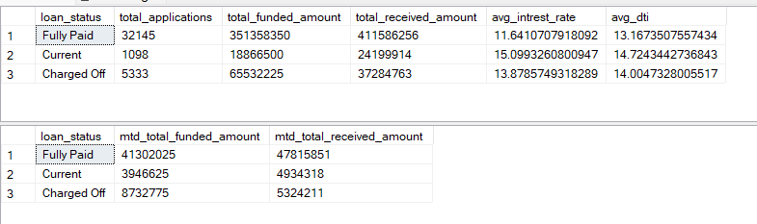

**----monthaly trend by issue date**

select

month(issue_date) as month_number,

datename(month,issue_date) as month_name,

count(id) as total_loan_applications,

sum(total_payment) as total_received_amount,

sum(loan_amount) as total_funded_amount

from loans

group by month(issue_date),datename(month,issue_date)

order by month(issue_date)

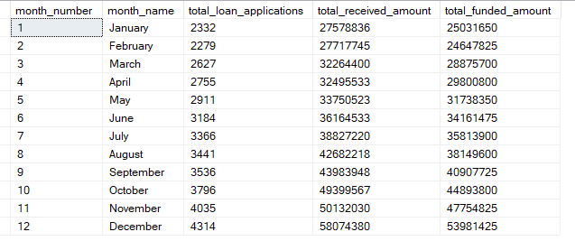

**---reginal analysis by state**

select

address_state as state,

count(id) as total_loan_applications,

sum(total_payment) as total_received_amount,

sum(loan_amount) as total_funded_amount

from loans

group by address_state

order by address_state

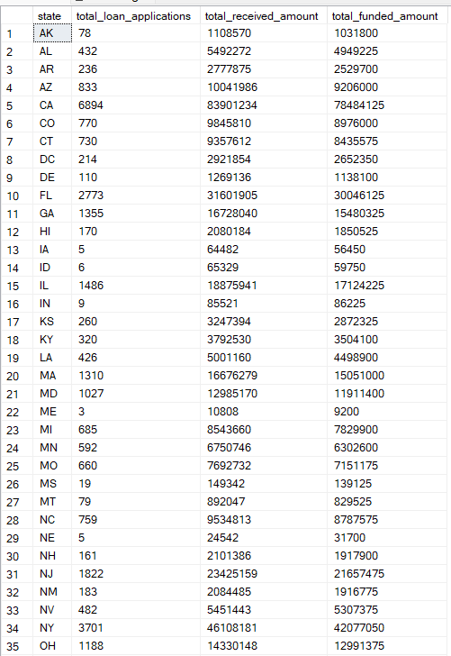

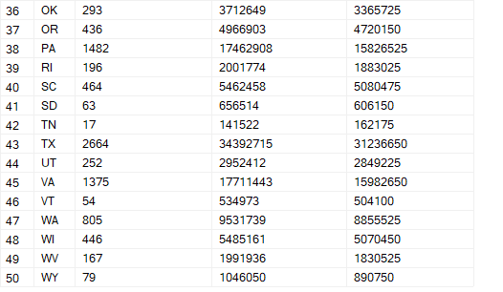

**---loan terma analysis**

select

term,

count(id) as total_loan_applications,

sum(total_payment) as total_received_amount,

sum(loan_amount) as total_funded_amount

from loans

group by term

order by term

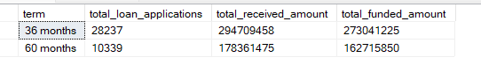

---lengh analysis

select

emp_length,

count(id) as total_loan_applications,

sum(total_payment) as total_received_amount,

sum(loan_amount) as total_funded_amount

from loans

group by emp_length

order by emp_length

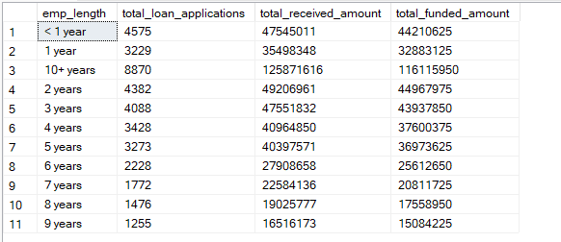

**--lone purpose analysis**

select

purpose,

count(id) as total_loan_applications,

sum(total_payment) as total_received_amount,

sum(loan_amount) as total_funded_amount

from loans

group by purpose

order by purpose

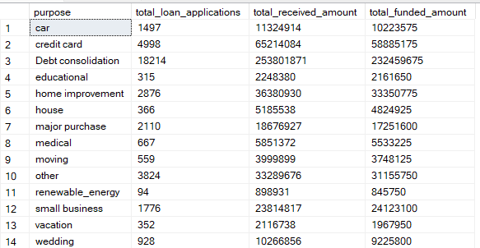

**---home ownershi anlysis**

select

home_ownership,

count(id) as total_loan_applications,

sum(total_payment) as total_received_amount,

sum(loan_amount) as total_funded_amount

from loans

group by home_ownership

order by home_ownership

